**PRODUCT SALES ANALYSIS**

*PHASE 1:*

**PROBLEM DEFINITION :**

The project aims to leverage IBM Cognos to conduct an in-depth analysis of sales data with the primary goal of gaining actionable insights to assist businesses in enhancing their inventory management and marketing strategies.

**PROBLEM STATEMENT :**

To analyze sales data and extract insights about top selling products, peak sales periods, and customer preferences. The objective is to help businesses improve inventory management and marketing strategies by understanding sales trends and customer behavior. This project includes defining analysis objectives, collecting sales data, designing relevant visualizations in IBM Cognos, and deriving actionable insights.

**PURPOSE OF ANALYSIS :**

The purpose of a product analysis report can be broadly broken down into three major facets:

1. Internal Analysis: which focuses on how you, as the business, can better improve, tweak and market your product.

2. External Analysis: which focuses on your potential customers, analysing how you can convince them that your product is worth buying, and why they should choose it over a similar competitor’s product.

3. Cost Analysis: which focuses on the end-to-end costs involved from manufacturing to sale -allowing you to analyse where you can potentially cut costs while still maintaining the quality of your product.

**DESIGN THINKING :**

***Analysis Objectives:***

1.Identify the top-selling products based on revenue and quantity sold.

2.Analyze sales trends over time to identify seasonality and growth opportunities.

3.Understand customer preferences by analyzing product categories and customer demographics.

4.Determine the effectiveness of marketing campaigns on sales.

5.Identify low-performing products that may need adjustments or discontinuation.

***Data Collection:***

Transaction Records: Collect detailed transaction data, including date, product ID, quantity sold, and revenue generated. This can be obtained from the company's sales database.

Product Information: Gather comprehensive product information, including product name, category, cost price, and supplier details. This can come from your product database.

Customer Demographics: Collect data on customer demographics such as age, gender, location, and purchase history, either from your CRM system or through surveys and feedback forms.

Marketing Campaign Data: Gather data on past marketing campaigns, including campaign type, duration, budget, and results.

*Data set for the analysis* : https://www.kaggle.com/datasets/ksabishek/product-sales-data

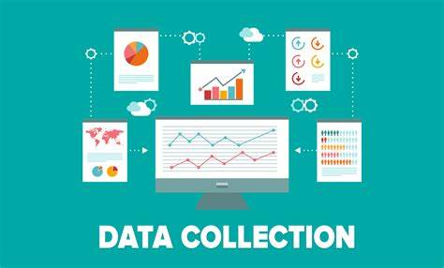

***Visualization Strategy:***

1.Use IBM Cognos to create interactive dashboards and reports that provide a holistic view of the sales data.

2.Create line charts to visualize sales trends over time, with options to filter by product category and location.

3.Generate bar charts to display the top-selling products by revenue and quantity.

4.Develop pie charts and heatmaps to showcase customer preferences based on demographics and product categories.

5.Utilize scatter plots to analyze the relationship between marketing campaign spending and sales revenue.

6.Incorporate drill-down capabilities to allow users to explore data at a granular level, such as by month, quarter, or region.

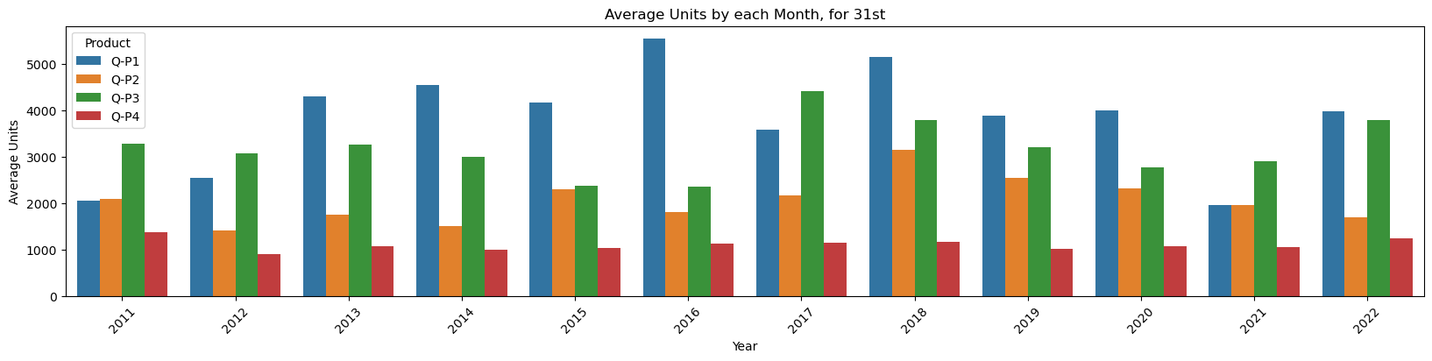

***Actionable Insights:***

Top-selling Products: Identify which products are performing the best and allocate more inventory and marketing resources to them.

Sales Trends: Recognize seasonal patterns and plan inventory accordingly. Identify growth areas and focus marketing efforts on them during peak seasons.

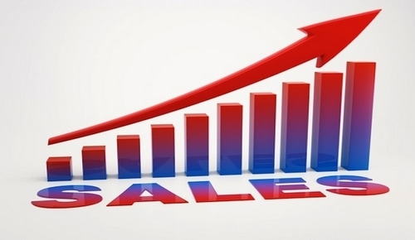

Customer Preferences: Tailor marketing campaigns and product offerings to specific customer demographics. For example, if younger customers prefer certain products, create targeted promotions for this group.  
 

Marketing Effectiveness: Assess the ROI of marketing campaigns and adjust strategies based on the data. Allocate more resources to successful campaigns.

Low-Performing Products: Determine if low-performing products should be optimized or discontinued to free up resources for higher-performing items.

By following these analysis objectives, data collection methods, and visualization strategies, can derive actionable insights from your sales data that will inform inventory management and marketing strategies to improve overall business performance.